
SRM Institute of Science and Technology
College of Engineering and Technology
DEPARTMENT OF ECE
SRM Nagar, Kattankulathur – 603203, Chengalpattu District, Tamilnadu
Academic Year: 2021-2022 (EVEN)
Test: CLAT-4 Date: 21-03-2022
Course Code & Title: 18ECC202J – Linear integrated circuits
Year & Sem: II year B.Tech IV sem. Max. Marks: 50

Course Articulation Matrix with PI:
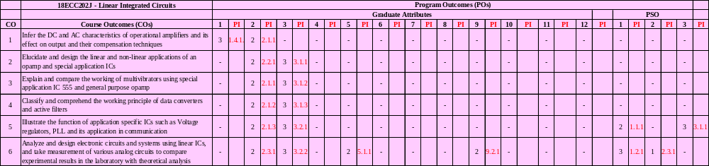

(10 x 5 = 50 Marks)
Instructions: Answer all the Questions
Q. No | Question | Marks | BL | CO | PO | PI Code
1 | Determine the difference voltage and an open loop op-amp gain in the circuit given below for the input voltages V₁=-5V and V₂=5V and output voltage V_{o}=20V.  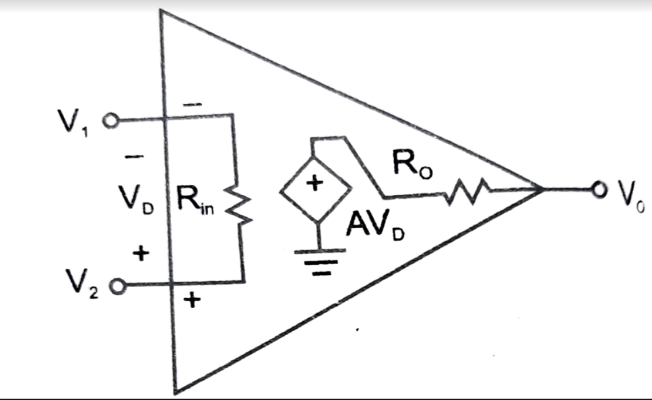 | 5 | 3 | 1 | 1 | 1.4.1
2 | In below figure is shown a differential amplifier using ideal op-amp.  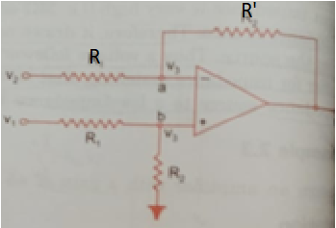  - Find the output voltage V_{o}  - Show that the output corresponding to common- mode voltage 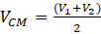 is zero if  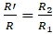. Find V_{o} in this case.  - Find CMRR of the amplifier if 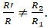 | 5 | 4 | 1 | 2 | 2.1.1
3 | A 741C op-amp is used as an inverting amplifier with a gain of 70. The voltage gain vs frequency curve of 741C is flat up to 30kHz. What maximum peak to peak input signal can be applied without distorting the output? | 5 | 3 | 1 | 1 | 1.4.1
4 | Determine the total offset voltage of the circuit shown in below figure. The circuit is a feedback op-amp with specified values of input offset voltage Vos = 4 mV and input offset current Ios = 150 nA.  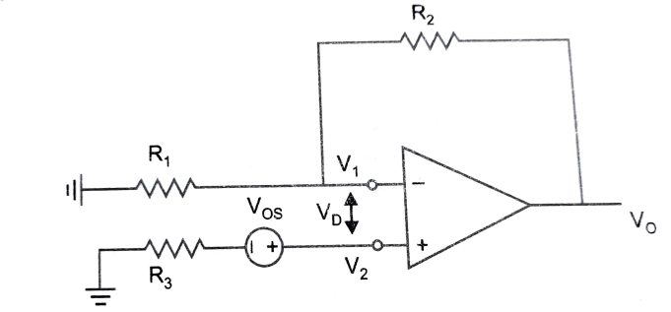 | 5 | 3 | 1 | 1 | 1.4.1
5 | Determine the loop gain of the compensated network shown in figure below if it has an uncompensated loop gain of 100 with magnitude 90° and the operating frequency of 1 MHz. Assume the compensation network element capacitance C= 0.0025 µF and resistance R =10KHz.  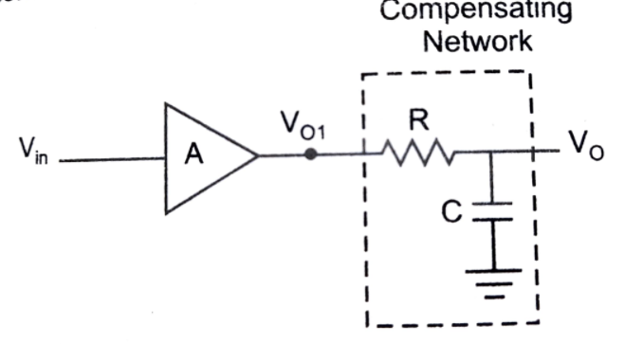 | 5 | 4 | 1 | 2 | 2.1.1
6 | Find V_{o} for the adder-subtractor shown in below figure.  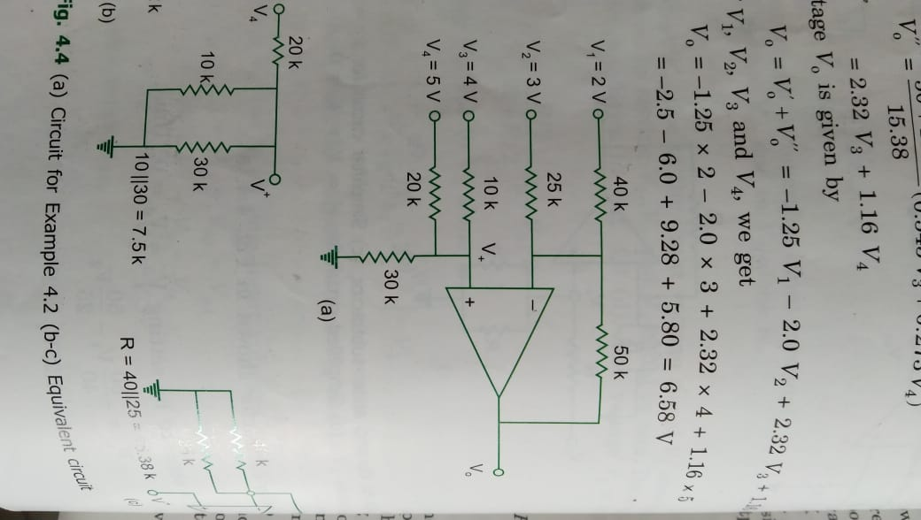 | 5 | 3 | 2 | 2 | 2.2.1
7 | In an integrator, the voltage V_{c} across capacitor is zero at t = 0; input voltage V_{I} = -1 V is applied at t=0. Determine the time constant required to reach output voltage +10V at t=1msec. Assume C value and find R value. | 5 | 4 | 2 | 3 | 3.1.1
8 | Determine the output voltage of the precision rectifier circuit shown in figure below for the input voltage V_{I} = 10V. Let the resistance values R₁ = 20 KΩ, and R₂ = 2R₁. Assume that the voltage drop across the diode is 0.7 V.  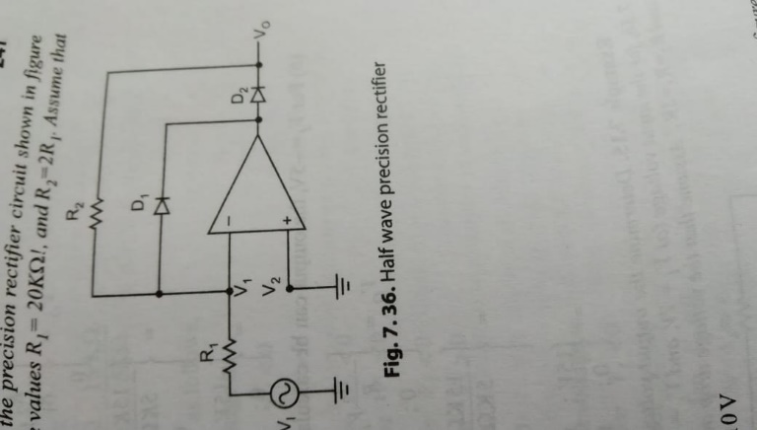 | 5 | 4 | 2 | 2 | 2.2.1
9 | Derive the output for 4-input averaging amplifier with diagram. | 5 | 3 | 2 | 2 | 2.2.1
10 | Design a summing amplifier that will produce an output voltage V_{O} = -(7V_{I1} + 15V_{I2} + 10V_{I3} + 3V_{I4}). Assume feedback resistance R₂ = 630 KΩ. | 5 | 4 | 2 | 3 | 3.1.1

Course Outcome (CO) and Bloom’s level (BL) Coverage in Questions
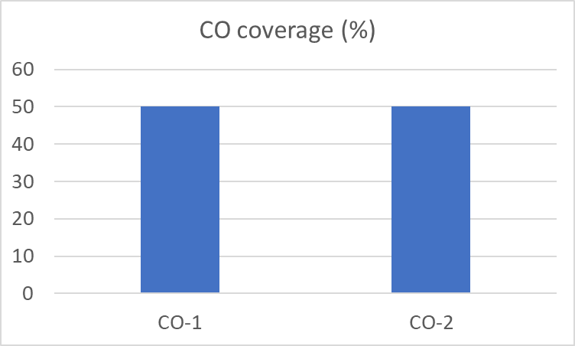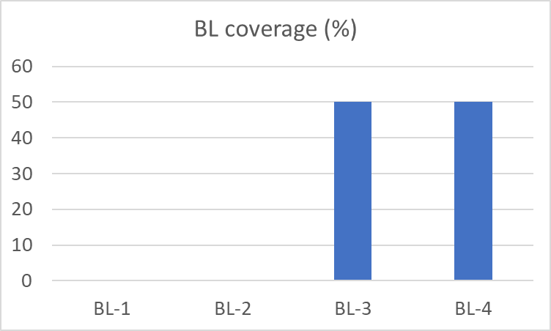

Signature of the Course Teacher

